New Professional Development Series chapter on detention of applicants for international protection in the context of the Common European Asylum System

* 8TH MAY 2019

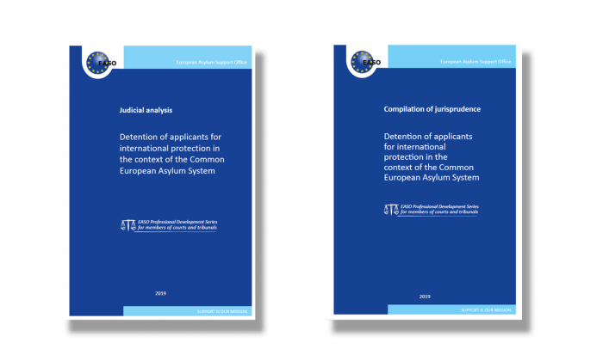

***Through its Network of Courts and Tribunals’ Members, EASO is developing Professional Development Series (PDS) and Professional Development Workshops intended for members of EU+ courts and tribunals.***

The PDS are developed **for judges by judges** under the coordination of EASO, with full respect of judicial independence. The series aim to offer courts and tribunals members **an overview of the full spectrum of EU international protection law and procedures**and to that end they comprise a judicial analysis, a compilation of jurisprudence and a judicial trainers guidance note (restricted to judicial trainers) for each subject covered. Under the auspices of the PDS, EASO organises professional development workshops that aim to provide members of courts and tribunals, including judicial trainers, expertise in the topics covered by the PDS.

Following recommendations from the Network, a new PDS chapter on **detention of applicants for international protection in the context of the Common European Asylum System** has been developed by a group of judicial experts from Austria, Bulgaria, Czech Republic, France, Germany, Greece, Slovenia together with a representative of UNHCR, making it **the first EASO publication to focus on this sensitive issue**. The new PDS chapter, which is the 9th of the relevant series, analyses the legal framework pertaining to detention and addresses relating key issues, such as the definition of detention and the definition of an applicant for international protection, the legal grounds for detention and relating evidential issues, the duration and conditions of this measure as well as alternative measures to detention and specific safeguards for applicants.

A full overview of available PDS may be found on <https://www.easo.europa.eu/courts-and-tribunals>.

The newly published judicial analysis on detention is available on <https://www.easo.europa.eu/sites/default/files/Detention-JA-EN-PDF.pdf> and the relating compilation of jurisprudence on <https://www.easo.europa.eu/sites/default/files/Detention-CJ-EN-PDF.pdf>.